IT2120- Probability and Statistics

Lab Sheet 07

IT24100344 - Gunasekara W L L

**Exercise**

**Q1)** 

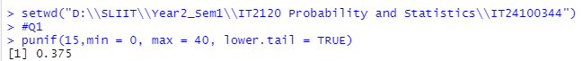

**Q2)**



**Q3)**

**i)**



**ii)**



